Introduction

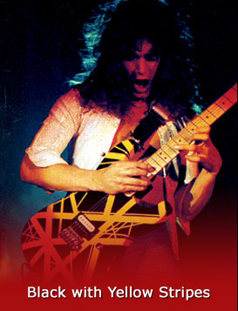
Van Halen is a rock band from the late 70’s. Why did I choose them? Cause they OWNS!!
The musicians in the band are among the worlds greatest, and when they began their journey in music they melted the world! I’m going to tell you about their biography, breakthrough and how popular they are today. Enjoy.

Edward Van Halen, guitar→

The material is taken from www.vanhalen.com, unofficial home site,
www.van-halen.com official home site, Wikipedia.org and some details from the one time magazine, “The 100 greatest guitar heroes”.

Van halen

Eddie and Alex Van Halen

As you may have realized, Alex and Eddie Van Halen are brothers. They where born 1955 and respectively 1957 in Nijmegen, Netherlands and moved to California 1965.
They where educated I piano as children. When they became a little older they got to play instruments of their choice, Edward first picked the drums and Alex the guitar. But when Edward was working back the money for the drums, Alex was playing as much as he could. This led to Alex being much better then Edward, so he picked up the guitar and turned out to be a natural.

Michael Antony
Born 1954 in Chicago. His father was an musician teacher, so he began to play at early age. He began with trumpet and at the age of 14 he started with bass, and is now considered one of the greatest bass players in the world.

Gary Cherone
Born 1964 in Malden, He was a member of “rock group extreme” before Van Halen and also participated in theatres as “Jesus Christ Superstar”. He also had three records with “rock group extreme” before joining Van Halen.

Former Members: David lee Roth, Sammy Hagar.

Michael Anthony Eddie Van Halen Alex Van Halen Gary Cherone
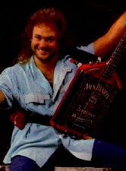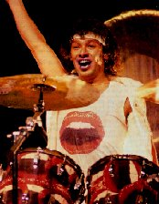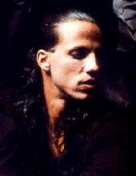

Breakthrough
The band spent three years playing at local hotels and bars in LA
and became very popular among the locals, Edward also became well known for his groundbreaking technique
1975, While playing at the LA club “The Starwood” They are spotted by the lead singer in kiss, Gene Simmons. He helps them by financing a demo with the songs “House of pain” and “runnin’ with the devil”. After that they got a contract with Warner bros from Gene Simmons recommendation.
You can say that this was their real breakthrough; they created an album
that went to a platinum with over six million sold albums (Van Halen I).
They also got full support from AOR radio, so almost everyone in the USA was listening to them. Then the success continued, The next two albums, (Van Halen II, Women and Children first) Sold just as good as the first one.
Then they let out several more albums, but the real fame and money came at 1984, when they released the songs jump, eruption (Legend) and hot for teachers. They where now millionaires.

How popular are Van Halen Today?

Van Halen doesn’t sell as many records as they did in the 80’s, because they stopped producing songs. Nowadays they bring in huge amounts of money on their tours and stuff they sell on the internet, they have two to three tours every year. Mostly they just play in USA, but they also do world tours. This summer, 2006 they are going to visit the Sweden rock festival.

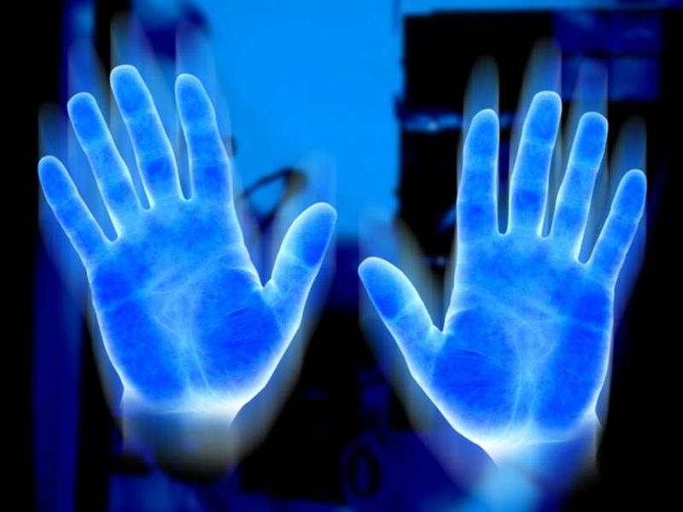
♦Finish♦

Van Halen has four members, Eddie Van Halen (guitar), Michael Anthony (bassist), Alex Van Halen (drums) and Gary Cherone (Vocalist and Rhythm guitar).

They started playing on hotels and bars In Los Angeles, found by kiss member Gene Simmons and got their contract with the Warner bros company.
Van halen 1977-forever
Van Halen does not sell many albums, they gain money on tours and selling Stuff with their name on it by internet.

It was very fun to work about Van Halen, it was easy to get information because the sources were reliable.
“Never give up your guitar, if you stick with it. You will be rewarded”- Eddie Van Halen





Sweet Jesus, He rocks!!!

Johnny Carlsson eca0508

