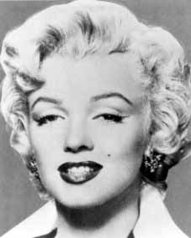

Marilyn Monroe

"If I play a stupid girl, and ask a stupid question, I've got to follow it through. What am I supposed to do, look intelligent?"
-Marilyn Monroe

Marilyn Monroe:

About Marilyn Monroe P.3-4

Sources P.5
Logg book P.6

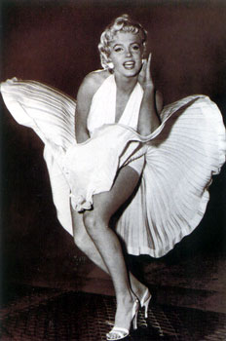

Birthname: Norma Jean Mortensson
Nickname: The Blond Bombshell

Height: 5' 5½" (1,66 m)

Marilyn Monroe:

Marilyn Monroe was an American moviestar.
She is/was most famous just because that she was so beautyfuil, sexy and also a really good actor.
In the 1950 she was very famous and almost everyone loved her. But private she was very unhappy.
She died 1962 (5 August) of a drug overdose.
The doctors and her friends thought it was a suicied, but someone thought that she had been killed.
Marilyn Monroe was born in 1926 (1th june), in Los Angeles (General Hospital). She was very young when she died she was just 36 years old. When Marilyn was born, her father bought a motorcycle and went north to San Francisco. So she grew up without her father, she didn’t even know where he was. Marilyns mother (Gladys), had many relationships, just to confuse Marilyn who the father was. But the real father wasnt there. Marilyns mother gave her the name; Norma Jean.
Gladys was extremely attractive, and she worked as a film-cutter for the RKO Studios. She suffered from mental illnes, and she was in and out of mantal institutions for the rest of her life. And because of that Marilyn had to live at different foster homes. She lived at her first foster home when she was nine, and she stayed there in two years. And after that two years she went to another foster home.
In 1942 when she was 16 years old she married 21 year old aircraft plant worker James Dougherty. But four years later they divorced (1946).
At that time Marilyn beacme a swimsuit model, and bleached her hair blonde.
Howard Hughes (worked at the RKO Studio) offered Marilyn a screentest, but an agent suggested that the 20th Century-Fox would be a better choice for her. Because they had a better and bigger studio. Marilyn was signed a contract for 6 month (125 dollar/ week).
She took part in her first movie in 1947, it was a little role in The Shocking Miss Pilgrim. And the next movie she took part in, didnt gave her a bigger role, it was also a very little role (Scudda Hoo ! Scudda Hey !)(1948).
Later the same year she was given a better role as Evie in Dangerous Years (1948). After that she started with modelling and she went to an actor school.
Later she worked for the Columbia Pictures, (Ladies of the Chours (1948). In this movie she sang two numbers). But she made just one movie with Columbia Pictures, then they dropped her. So Marilyn started with the modeling again.
In 1949 she took part in another movie called Love Happy, the same year she posed for Playboy (a very famous magazine).
In 1950 she took part in two movies ; The Asphalt Jungle, and All About Eve.
In 1951 she had a role in Love Nest, and now the public started to like that they saw. They liked her as a moviestar.
She took part in two films 1952 (Dont bother to Knock, and Monkey Buisenss).
1953 she started daiting a baseball player with the name Joe Dimaggio. The same year she made the movie Gentlemen Prefer Blondes.
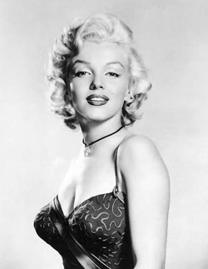
In 1954 Joe and Marilyn divorced.
1962 it looked like her carrier were finished.

"I want to be a big star more than anything. It's something precious."
-Marilyn Monroe

Sources:

http://www.imdb.com/name/nm0000054/bio
Written by: Ed Stephan <stephan@cc.wwu.edu>

www.google.com
(Pictures, Marilyn Monroe)

Logg Book:

First week:
Tuesday:
Today I have been looking for some fact about Marilyn Monroe. I found a really good page, but the english vas very bad. So I didnt know if it was a good source. So I didnt write anything today, yeah I made the front page: )
I hope I find a better page tomorrow. Because I am going to find fact about Marilyn and write about her, and her life. Just because I like her! : )

Wednesday:
Today i found a good page again but with bad english. I have been searching at the Google.se and ne.se. Google gave me about 11 000 000 pages about her! And I have no time to look at all of them, haha. But i compered the text I find today with the text I found yesterday (at google.se), and it says nearly the same. So I think I’ll use it ! I have also been looking for some pictures.

Friday:
Today I have been writing down things about Marilyn. And I have learned some new things about her, I didnt know that her mother was mental ill, or that she didnt know who her father was.

Second week:
Tuesday:

Today I have nearly finished my projekt work!
But not really, I have to find some more pictures, and then I am finish: )
So I will send this to Madde tomorrow, because I am so tired now.

Wednesday:

Today I send this work away !

Third week:
Wednesday:

Something was wrong last week !
Because I send it, but Madde havent seen it, I dont know, but something had to be wrong with our internet or my mail. So I’ll try again today.

