Introduction

I’ve chosen this subject because of my own interest in dance and where it comes from. As you already know I think dance is a good way to express emotions and feelings to an audience, and for me it is also a way of channel feelings in to an expression that don’t harm anyone. I dance when I’m sad, happy, angry and so on, and for me it is very important as a part of my life. I can’t stand the mere thought of not being able to move to the sound of music or just move like I feel. Therefore I write this essay about modern dance. This is one of the dances I know and I also feel very strong for it. Some of the sentences in this paper is a bit strange, but it’s because I did not know how to put the words so it would actually present what it means. Also lots of the words in my sources were very difficult, so that I could not understand them so I have worked with a dictionary to find synonyms for words that I had to change. So even if this is just a summary of other articles, fact books and websites, I have learned lots about modern dance and also thought my self quite a few new words! So for me this essay have been a personal success.

Dance [Old High Ger. danson=to drag, stretch], the art of precise, expressive, and graceful human movement, traditionally, but not necessarily, performed in accord with musical accompaniment. Dancing developed as a natural expression of united feeling and action.

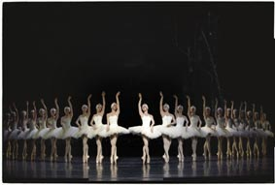

The Beginning of Modern Dance

The Development started in the 18th century, mainly in USA and in Central Europe (Germany), modern dance is a collection of modern arts (movements) and music that is experimental. The development of modern dance begun at the end of the 18-hundreds the ones that were first was; Isadora Duncan, Loie Fuller, Ted Shawn and Ruth St. Denis in the USA, Rudolf von Laban and Mary Wigman in Germany. Each one stood up against the classic academic ballet and against the underestimated show dance. Each one was searching to inspire the audience to a new view of the art of dance, a goal shared by almost all modern dancers. Early dancers in the United States as Isadora Duncan shocked and/or delighted audiences by showing her parts of her body and soul in what she called “free dance.” Wearing only a simple tunic like the Greek vase figures that inspired many of her choreography’s, she weaved and whirled in flowing natural movements that sprung up, she said, from the stomach (solar plexus). She aimed to personify the emotions in the music that was her motivation, daringly chosen from the works of great composers including Beethoven and Wagner. Even though Duncan started schools and had many imitators, her improvisation-technique was too personal to be carried on by others.

The work of the two other American pioneers was far less abstract although no less free. Loie Fuller used dance to imitate natural phenomena’s: flames, flowers , butterflies and so on. Experimenting with stage lighting and costume, she created illusionistic effects that remain unique in the history. That’s also what made Fuller so famous in the art of modern dance.

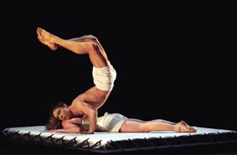
The scenic effects achieved by Ruth St. Denis had a different source, the ritual inspired dance of Asian religions. She relied on time according costumes and very improvised movements to suggest the dances of India and Egypt and to achieve mystical feelings. With Ted Shawn, who became her partner and husband in 1914 and who advocated and embodied the vigor of the virile male on the dance stage, St. Denis expanded her program to include dances of Native Americans and other ethnic groups. In 1915 St. Denis and Shawn formed the Denishawn Dance Company, which raised the popularity of modern dance all over the United States and other countries, it also encouraged the leaders of the second generation of modern dance: Martha Graham, Doris Humphrey, and Charles Weidman amongst others.

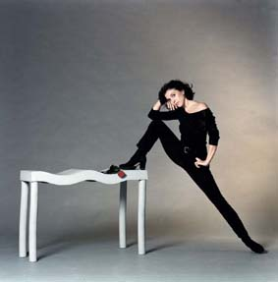
The Second Generation in America

At the end of the 1920s those who stood up against the art of the exotic dances and commercialism of Denishawn started to produce their own choreography’s and start there own companies. Their dances were based on new techniques for the expression of human passions and social themes. Martha Graham found the breath pulse the primary source of dance; shifting the contraction and expansion of the torso and flexing of the spine caused by breathing, she devised a base for movement that for her represented the human being's inner struggle.
To Doris Humphrey, gravity was the source of movement; the area in between balance and imbalance of the moving body, fall and recovery, was one's conflicts with the surrounding world. Don’t using the usual, easy movement patterns and using the most simple costumes and the most simple stage effects, Graham and Humphrey composed dances so strong, intelligent, and very dramatic only to shock and anger audiences accustomed to being pleased by graceful dancers.
Graham tried themes from America, Greek mythology, and the Old Testament; she viewed music only as a background for the dance.
Humphrey experimented more with sound, in a work 1924 she stopped using music and made a performance in silence, later on she used non-musical sound effects, including spoken texts and hysterical laughter. Her themes were social and often heroic, for example; the trilogy New Dance (1935), where she brings up human relationships.
Charles Weidman's type miming dance taken from everyday situations provided a different kind of social comic satire. Gaining lots of fame, the Graham and Humphrey-Weidman companies dominated modern dance for 20 years, until last year when Graham died and the company had lots of economical problems the company now lies on ice until someone with the funds will take over and start running it again (this will probably not happened).

Later Dancers

At the end of World War II, young choreographers had begun breaking the rules of the modern dance establishment, creating dances that had no theme, expressed no emotion, only using the dance vocabulary of fall and recovery, contraction and release. Sybil Shearer's random fantasies, Katherine Litz's surrealistic vignettes, and Erick Hawkins's impressionistic soft rhythms changed the usual ideas of choreography. They had no desire to uplift or inform.
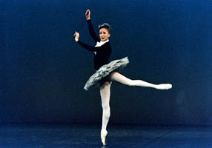
One of this third generation of modern dancers is Merce Cunningham, whose company bred avant-garde choreographers for more than 25 years. Cunningham freed dance from all bonds, taking away all usual patterns of the ordinary choreography’s. He also released dance from traditional musical bonds by using electronic music and other compositions of his musical director, John Cage. In addition, he freed his own choreography from structural limits by using techniques of chance, such as throws of the dice, to determine the order in which sections of a work should occur.
In 1957 Paul Taylor, a Cunningham and Graham veteran, presented an evening of minimal dance, which consisted of Taylor standing on the stage alone in street clothes and making only tiny changes in posture to the accompaniment of the recorded voice of a telephone operator announcing the time at 10-second intervals; outraged dance critics cursed and/or ignored the performance. His company ultimately became one of the most important of the post–World War II troupes. Another of the third generation, choreographer Alvin Ailey, who was influenced by Lester Horton, combined elements of modern, jazz, and African dance in his work. The company he started 1958 has been internationally confirmed and has brought recognition to many African-American and Asian dancers.
The social and artistic arts of the 1960s supplied a good ground for even more radical choreographers into what later became known as post-modern dance. Twyla Tharp did experiment with any sound accompaniment that might distract the viewer's attention from the dance itself. She also took dance out from the theatre, staging it in spaces like as the staircase of the Metropolitan Museum of New York City and New York's Central Park. Yvonne Rainer was one of the first to use improvisation base on ordinary, non-dance movements ranging from acrobatics, to military marching, to sports and games.
Sources:
www.infoplease.com
ballet & modern dance Susan Au(1988)
europe dancing Andrée Grau & Stephanie Jordan(2000)
Therpischore in sneakers Sally Banes(1987)
Fridans Lilian Karina & Lena Sundberg(1989)

