Rudyard Kipling

This assignment is about an author with the extraordinary, narrative gift for writing and still today is appreciated around the world for his most popular and familiar Jungle books about Mowgli, Baloo and Bagheera, and also for his short stories and remarkable proems. Now, after my work, writing about his life, I’m very impressed of him.
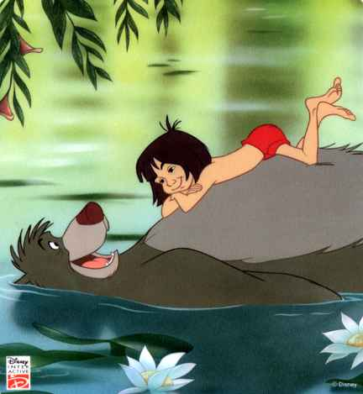
Rudyard Kipling was born December 30th, 1865 in Bombay, India. He lived his earliest years in Bombay and were blissfully happy in an India, full of exotic sights and sounds, with his father John who was an arts and crafts teacher and mother Alice who was a former. At that time India was ruled by Britain. At the age of five he was sent to England to stay with a foster family. There he was desperately unhappy, but this experience later on coloured some of his writings. When he got twelve he went to a college, were the headmaster knew Kipling’s parents well. The headmaster fostered his literary ability. Kipling had poor eyesight, which handicapped him at the game field, but soon he would blossom in his literary ability. He got to wear eyeglasses and got teased by the other students. He later one wrote one of his most popular books, Stalky & Co which is based on his schooldays.
At the age sixteen, year 1882, he returned to India, to a village called Lahore, were his parents lived by now. There he worked as a journalist until 1887 and later he worked at its sister paper, as an editor and overseas correspondent. At his limited spare time he wrote many remarkable poems and stories which were published alongside his reporting. Later on these were collected as a book and this book laid a basis of his future fame.
1889, Kipling returned to England, were his poems and short stories got instant success.
After his American collaborator friend died, he married the passed away friend’s, sister, Carrie Wolcott 1892. They went around the world and later settled down in Carries family home in Vermont, USA. Here Kipling wrote Captains Courageous and maybe his most familiar and popular books, The Jungle books. Their first two children, Josephine and Elsie were also born here. Josephine later on died abrupt and after her dead things would never be the same again. 1902 the family moved back to Sussex, in England were John, their son, got born. Kipling keeps writing and because of living during the World War period, he was involved in some politics about the war and the British Empire and had many opinions, which often appeared in his writings. He got some critics and was called “prophet of British imperialism”. 1907 he receives the Nobel Price in Literature which made him the first English language writer to receive the prize. Between years 1922 and 1925 he worked a principal at a University. 1935, his last remaining year, he wrote his autobiography, Something of myself which was published posthumously. January 18th, 1936, at the age seventy-one he dies. He got buried in Poet’s corner at Westminster Abbey, in London.
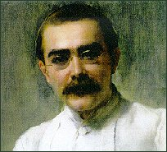

Sources:
http://www.kipling.org.uk/kip_fra.htm
http://en.wikipedia.org/wiki/Rudyard_Kipling
http://www.kirjasto.sci.fi/kipling.htm

